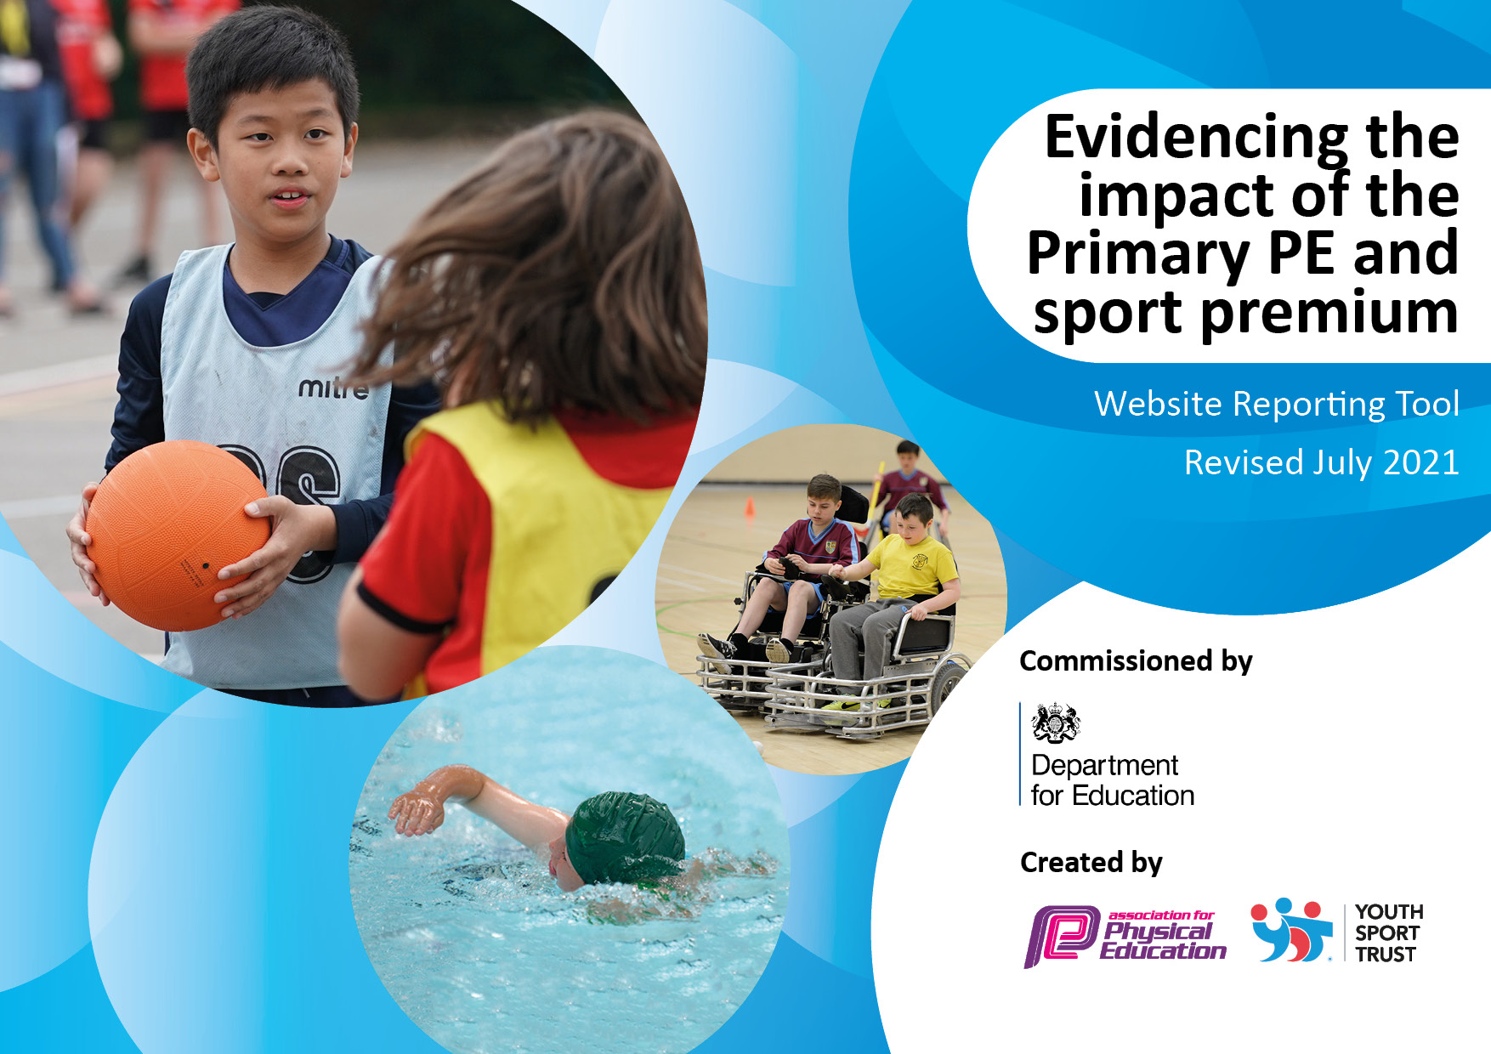
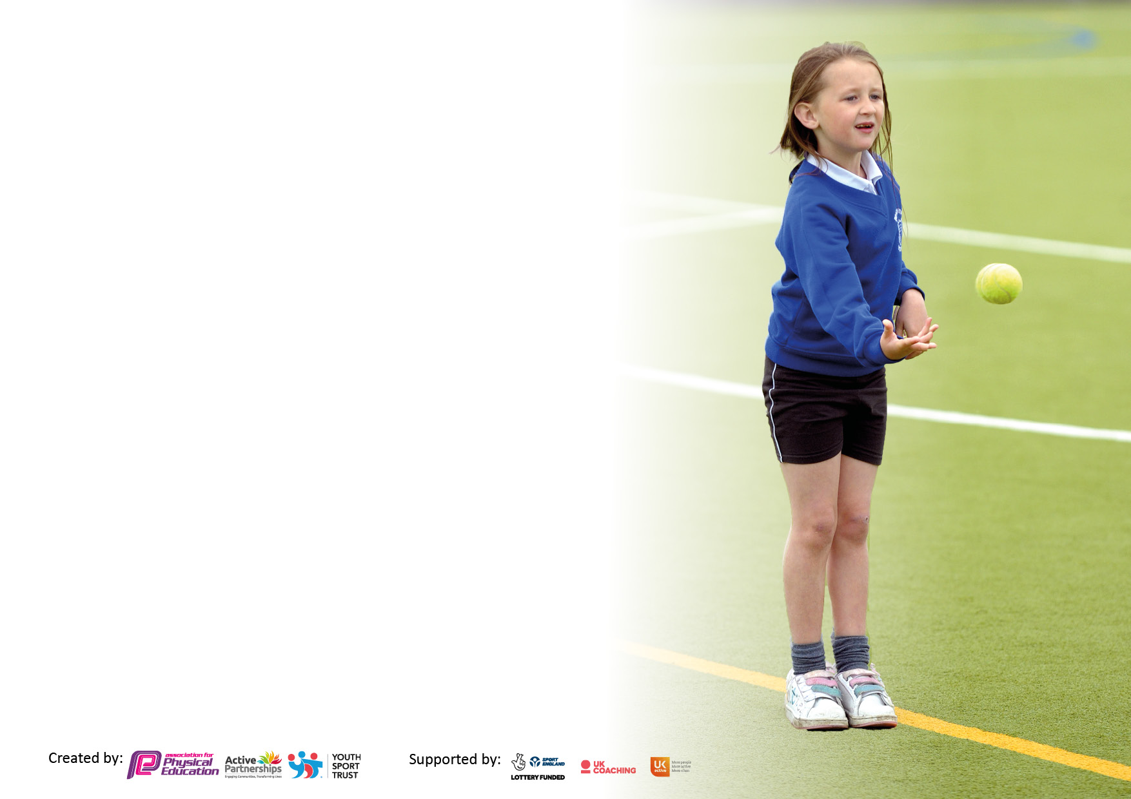

It is important that your grant is used effectively and based on school need. The Education Inspection Framework makes clear there will be a focus on ‘whether leaders and those responsible for governors all understand their respective roles and perform these in a way that enhances the effectiveness of the school’.

Under the Quality of Education Ofsted inspectors consider:
Intent - Curriculum design, coverage and appropriateness
Implementation - Curriculum delivery, Teaching (pedagogy) and Assessment
Impact - Attainment and progress

To assist schools with common transferable language this template has been developed to utilise the same three headings which should make your plans easily transferable between working documents.

Schools must use the funding to make additional and sustainable improvements to the quality of Physical Education, School Sport and Physical Activity (PESSPA) they offer. This means that you should use the Primary PE and sport premium to:

- Develop or add to the PESSPA activities that your school already offer
- Build capacity and capability within the school to ensure that improvements made now will benefit pupils joining the school in future years
- The Primary PE and sport premium should not be used to fund capital spend projects; the school’s budget should fund these.

Pleasevisitgov.ukfortherevisedDfEguidanceincludingthe5keyindicatorsacrosswhichschoolsshoulddemonstrate animprovement.Thisdocumentwillhelpyoutoreviewyourprovisionandtoreportyourspend.DfEencouragesschools to use this template as an effective way of meeting the reporting requirements of the Primary PE and sport premium.

We recommend you start by reflecting on the impact of current provision and reviewing the previous spend.

Schools are required to publish details of how they spend this funding, including any under-spend from 2019/2020, as well as on the impact it has on pupils’ PE and sport participation and attainment. All funding must be spent by 31st July 2022.

We recommend regularly updating the table and publishing it on your website throughout the year. This evidences your ongoing self-evaluation of how you are using the funding to secure maximum, sustainable impact. Final copy must be posted on your website by the end of the academic year and no later than the 31st July 2021. To see an example of how to complete the table please click HERE.
Created by: Supported by:

Details with regard to funding
Please complete the table below.

Total amount allocated for 2022/23 | £17867
Total amount of funding for 2022/23. To be spent and reported on by 31st July 2023. | £17527
How much (if any) do you intend to carry over from this total fund into 2023/24 | £9609
Total amount allocated for 2023/24 | £17,875
Total amount of funding for 2023/24. To be spent and reported on by 31st July 2024. | £27,484
Swimming Data
Please report on your Swimming Data below.

Meeting national curriculum requirements for swimming and water safety.  N.B. Complete this section to your best ability. For example you might have practised safe self-rescue techniques on dry land which you can then transfer to the pool when school swimming restarts.  Due to exceptional circumstances priority should be given to ensuring that pupils can perform safe self rescue even if they do not fully meet the first two requirements of the NC programme of study | Yes – access to structure programme at Caldy Grammar pool with trained instructors.
What percentage of your current Year 6 cohort swim competently, confidently and proficiently over a distance of at least 25 metres?  N.B. Even though your pupils may swim in another year please report on their attainment on leaving primary school at the end of the summer term 2020.  Please see note above | 53%
What percentage of your current Year 6 cohort use a range of strokes effectively [for example, front crawl, backstroke and breaststroke]?  Please see note above | 75%
What percentage of your current Year 6 cohort perform safe self-rescue in different water-based situations? | 50%
Schools can choose to use the Primary PE and sport premium to provide additional provision for swimming but this must be for activity over and above the national curriculum requirements. Have you used it in this way? | No

Action Plan and Budget Tracking
Capture your intended annual spend against the 5 key indicators. Clarify the success criteria and evidence of impact that you intend to measure to evaluate for pupils today and for the future.

Academic Year: 2022/23 | Total fund allocated: | Date Updated:
Key indicator 1: The engagement of all pupils in regular physical activity – Chief Medical Officers guidelines recommend that primary school pupils undertake at least 30 minutes of physical activity a day in school |  |  |  |  | Percentage of total allocation:
 |  |  |  |  | £7,300 = 42%
Intent | Implementation |  |  | Impact
Your school focus should be clear what you want the pupils to know and be able to do and about  what they need to learn and to  consolidate through practice: | Make sure your actions to achieve are linked to your intentions: | Funding allocated: |  | Evidence of impact: what do pupils now know and what can they now do? What has changed?: | Sustainability and suggested next steps:
Create as many opportunities as possible for physical activity and daily exercise to become a routine part of the school day for our children.  To enhance the curriculum through physical activity and to teach the children about teamwork, healthy lifestyles and positive mental health. | Get Up and Go club delivered by TAs started increasing mental health, wellbeing and attentiveness before school. |  | Provided by school staff.  Cost of staffing 1 day per week.  TBD |  | This has not been offered this year and is planned for Sept 2023 due to staff involvement in catch up sessions.
 | VR to train new midday assistants on Jenny Mosely techniques and activities  Signs and playground equipment to support Jenny Mosely lunchtime Activities  New stock for lunchtime equipment  Replacement mats  Outdoor table tennis tables x2 (Sport safe) |  | £100  (speak to VR)  £600  £500  £400  £1600 | A wide range of activities is available during lunchtimes. TAs have enhanced skills, which can be used across the age ranges.  Storage will increase the life of the equipment. It will also allow more equipment to be used on the playground and stored safety for playtimes. It will be accessible for staff whilst supervising children.  This trolley will increase the ability to move mats to other areas of the school. The 4-wheel trolley will allow us to move the mats for outdoor lessons and also reduce replacement as mats will not be damaged and instead  be in a safe-accessible trolley.  Providing a range of new sports to children throughout the school day. | Update equipment each year.  Continue to offer training for TAs and middays to refresh, embed and further develop staff skills.  Purchased with cupboards locked outside of school hours.  Smaller mats purchased and provision of trolley.  An annual focus on less active children – including a variety of approaches/activities.  Not purchased this year and rolled over to order for next year.
 | Bike it Breakfasts |  | £100 | Increase the number of children and the profile of the benefits of regularly travelling to school by bicycle and exercising. | Bike it Breakfasts were run on a termly basis and hugely successful with >100 vehicles on each occasion.  Continue to count number of children cycling/scooting to school /using bike rack on Bike-it days.
 | Forest School  To improve forest school area- more outdoor learning equipment in 20/21 so that children can spend more time in larger groups in forest school as more resources will be available. Suggested purchases include: swing, all weather canopy, balancing logs, den building equipment, outdoor storage  Gardening/maintenance costs  Y1 Outdoor provision  Provide additional resources and equipment to provide further opportunities for active learning and play. |  | £3000  £200 | Walking to Forest School weekly in all weathers ensures our all children have regular exercise plus engaging in physical activity once there for example walking and jumping in and out of the tyres, using the rope swings etc.  Outdoor provision for EYFS and Y1 provides additional opportunity for physical activity during the school day. This all-weather sporting surface now allows for outdoor provision for all classes throughout the school day. It is a safe surface for all classes to access additional outdoor PE sessions e.g. gymnastics and can be used all year round. The kitcamp kit allows all children to develop teambuilding, climbing, jumping and lifting skills to put together a role play area. This can be used across year groups and for cross curricular links. Kitcamp panels are engineered to be robust enough to support children and light enough for kids to carry around. | Continue to replace and update equipment for outdoor provision including forest school annually.  Staff to be trained.  Gardening and maintenance costs will be ongoing.  Provision of brick fire pit in forest School.  Further ned identified as large scale construction equipment which will be factored into 2023/24 plan.
 | Midday |  | £3500 | To facilitate a MDA running activity sessions during each lunchtime (scramblers, scooters, etc). | An effective session which encourages teamwork and activity. High engagement of pupils.
Key indicator 2: The profile of PESSPA being raised across the school as a tool for whole school improvement. |  |  |  |  | Percentage of total allocation:
 |  |  |  |  | £1829.99 = 10.4%
Intent | Implementation |  |  | Impact
Your school focus should be clear what you want the pupils to know and be able to do and about  what they need to learn and to  consolidate through practice: | Make sure your actions to achieve are linked to your intentions: | Funding allocated: |  | Evidence of impact: what do pupils now know and what can they now do? What has changed?: | Sustainability and suggested next steps:
Continue to further improve the high profile of competitive sport, when regulations allow by celebrating the success of school teams and inspiring children to join in and compete.  Fitness tests completed at beginning and end of each term with emphasis on self- improvement. Target least fit (NC lunchtime club) | Match reports at Celebration Assembly and in Newsletters when competitive sport resumes.  Weekly Sports/PE trophy.  Team displays and new PE/Sports Notice board to raise profile.  Badges for team members and ribbons, stickers and equipment for Sports day.  Replace PE trophy  New football team kit  Stickers for sports day  New goals on backfield (samba goals) to be implemented. They need to be moveable so we can change pitch size depending on year group. |  | £50  £10  £390  £30  £220 | Did not occur due to COVID restrictions. To continue next year.  Achievement trophy for PE raises the profile of the importance of PE within the curriculum.  Sports day successfully went ahead. Children showed competitiveness to win a sticker, reward and trophy for their house team. Our whole school egg and spoons were updated this year. KS1 used the shorter spoons and KS2 used the new, longer spoons. This provided progression across the key stages and allowed children to be more challenged.  Football kits and staff tops to be ordered next year.  New samba goals are now available on our back field. | A full timetable of events offered with REACH collaboration and across Wirral competition. Oak Trees MAT offers enhanced and further opportunities for children to engage with inter-school competitions and events.  Damaged incurred to goalposts means that they one needs to be replaced but used extensively through school time and for events such as Summer F  No cost to school for goals but we will need to replace them in 2022/23
Continue to work with specialist coaches and visitors to raise the profile of PESSDA and introduce new sports and physical activity. | Assemblies and clubs for Judo, Fencing and Archery  Yoga session for each class (autumn term) to support recovery curriculum  Chance to Shine (Cheshire Cricket Club)  Personal Safety class session for Y6.  Provide Fitness club for less active. |  | TBD  £200  £75 | Staff and stakeholders aware of the focus and work of PESSDA in improving sports provision.  Range of activities made available to children to develop skills, knowledge and passion/past times. | Repeat personal safety each year as part of Y6 transition to secondary school
Continue to provide role models to inspire sporting achievement but also to exemplify positive characteristics in line with our school motto: Be kind, Work hard, Never give up. | Books/Recourses POOC Person of Outstanding Character) assemblies  Order more books to put on P.E display.  Role model displays up in hall of key sporting figures- teachers to refer to during P.E lessons |  | £300 | Children are aware of POOC and can discuss their achievements and positive personality traits including growth mindset.  Children identify that determination and resilience key attributes in any sport. | Linked to themed days and assembly calendar throughout the year (Paralympian visit 27.09.21)

Key indicator 3: Increased confidence, knowledge and skills of all staff in teaching PE and sport |  |  |  | Percentage of total allocation:
 |  |  |  | £5,989.50=34%
Intent | Implementation |  | Impact
Your school focus should be clear | Make sure your actions to | Funding | Evidence of impact: what do | Sustainability and suggested
what you want the pupils to know | achieve are linked to your | allocated: | pupils now know and what | next steps:
and be able to do and about | intentions: |  | can they now do? What has
what they need to learn and to |  |  | changed?:
consolidate through practice:
Continue to offer a range of activities to challenge and inspire our children by offering a range of clubs and by inviting sports coaches to share their expertise. | Bike-it Breakfasts and Bikeability  Before school football when regulations permit  Oaklands OAA Residential for Y6 (staffing costs)  Lacrosse equipment to develop a Club  Y6 playmaker award to develop leadership skills in sports. Leading games and facilitating play leader roles (Kick start education)  Lunchtime clubs (Ace of Sports) | (see KI 1)  £700 (see KSI 1)  £300  (see KI 2)  £580  £1818 | Increase the number of children and regularity with which they cycle to/from school and exercise.  Nurturing personal development for Y6.  The playmaker award is a nationally recognised programme of leadership training that is designed for use in a variety of educational settings as a six hour course and focuses on developing learner’s leadership skills within sports. This continue as we appoint play leader roles.  These clubs will take place with a highly qualified coach. They will provide an opportunity for skills development throughout all year groups. These clubs will run all year around and provide an opportunity to increase physical activity in our least physically active children and increase multi skills throughout our school.
Key indicator 4: Broader experience of a range of sports and activities offered to all pupils |  |  |  | Percentage of total allocation:
 |  |  |  | £3483=19.9%
Intent | Implementation |  | Impact
Your school focus should be clear | Make sure your actions to | Funding | Evidence of impact: what do | Sustainability and suggested
what you want the pupils to know | achieve are linked to your | allocated: | pupils now know and what | next steps:
and be able to do and about | intentions: |  | can they now do? What has
what they need to learn and to |  |  | changed?:
consolidate through practice:
Continue to offer a range of activities to challenge and inspire our children by offering a range of clubs and by inviting sports coaches to share their expertise. | Bike-it Breakfasts and Bikeability  Before school football when regulations permit  Oaklands OAA Residential for Y6 (staffing costs)  Gymnastics club whole-school club (Ace of sports)  Multi sports whole-school club (Ace of sports)  KS2 football club (Ace of Sports)  Judo Education personal safety lesson  Edsential PE Scheme of Work | £100 (see K.I.1)  £700 (see K.I.1)  £300  -  SEE KI3  £75  £288 | These clubs will take place with a highly qualified coach. They will provide an opportunity for skills development throughout all year groups. These clubs will run all year around and provide an opportunity to devise a new school football team. Increasing opportunities to be a part of competitive sport competitions.  Offering a wider range of activities for children to access both indoors and outdoors safely. These mats will be used to teach yoga, gymnastics and other balancing activities.  Y6 will be offered a personal safety Judo Lesson.  The scheme will offer high quality PE lessons and assessment tool. There will be a broader range of sports to offer each year group, including a vast range of skills taught. | Look at providing y6 with this training yearly in preparation for play leader role.  Staff yoga training and whole-school yoga day/week.  To continue with Y6 each year.  Review each year.

Key indicator 5: Increased participation in competitive sport. |  |  |  | Percentage of total allocation:
 |  |  |  | £2300=12.8%
Intent | Implementation |  | Impact
Your school focus should be clear | Make sure your actions to | Funding | Evidence of impact: what do | Sustainability and suggested
what you want the pupils to know | achieve are linked to your | allocated: | pupils now know and what | next steps:
and be able to do and about | intentions: |  | can they now do? What has
what they need to learn and to |  |  | changed?:
consolidate through practice:
Further develop opportunities for competition in school and with other schools when regulation allow. | Continue to compete in competitions when they begin again (may be a delay starting due to COVID 19).  Staffing costs for liaison/organisation of fixtures and events.  Staffing costs to enable staff members to take children to fixtures and events that take place during the school day  Football pitch and playing field maintenance  Admin costs for club and match organisation | £200  £600  £700 (see KI 4)  £800 (see KI 4)
Projected spend 2022/2023= £ 18,602.49 Actual Spend 2022/2023 = £7918

Signed off by
Head Teacher: | R. Dixon
Date: | 18/07/23
Subject Leader: | N. Collins/R. Dixon
Date: | 18/07/23
Governor: | S Douglas
Date: | 18/07/23

