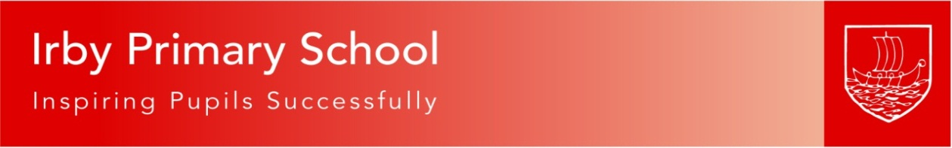

IRBY PRIMARY SCHOOL

EQUALITY PLAN
(2021-2025)
Equality Monitoring Plan 2021-22
Strand/targets | Strategies | By Whom | When | Success criteria | Evidence Base/Outcomes
Monitor and analyse pupil achievement by ethnicity, gender and disability and act on any trends or patterns in the data that require additional support for pupils. | Achievement data analysed by ethnicity, gender and disability. | Headteacher / SENCo | Dec, March and June. | Analysis of teacher assessments /annual data demonstrates the gap is narrowing for equality groups and is a focus for school improvement. | Reference HT data analysis and Pupil Progress Meeting proforma, analysis and meetings.  School wide focus upon TEs tracking all pupils’ progress and attainment.  Ongoing.
Publish and promote the Equality Plan and Policy through the school website. |  | Headteacher/  Computing Lead | February | Policy and plan on school website. Updated annually. | Reference policies and Equality tabs on website.
Ensure that the curriculum promotes role models and heroes that young people positively identify with, which reflects diversity in terms of ethnicity, gender, sexuality and disability. | Curriculum review and subject leader monitoring | Curriculum Committee  /Art subject leader. | Sept – July | Diversity reflected in curriculum planning, assemblies and school displays across all year groups  Evidence from Community Governors display walk. | In all subjects focus upon identifying role models – science, history, art, etc.  This is being developed through full review of foundation curriculum.  Reference assemblies timetable
Ensure that displays in classrooms and corridors promote diversity in terms of ethnicity, gender, sexuality and ethnicity. | Art Subject leader monitoring.  PHSE lead to display books in corridor and classrooms. | Art Subject leader | Ongoing |  | Reorganisation of displays planned for Summer 2022 with focus upon diversity and equality.
Continue with Picture News promoting British Values and Equality and Respect and more opportunity for age appropriate smaller group discussion in the classroom. Trial EYFS Picture News (Spring 2)  Introduce Ethos Bee Assemblies linked to character. | Ethos Bee and Picture News assemblies.  New assembly tracker produced. | PSHE lead, EYFS lead and Headteacher | Ongoing | Positive engagement of all children in assemblies and recall of themes and messages covered. | Picture News resources are circulated each week to class teachers for use as collective worship and class assemblies. Singing practice, two KS assemblies and Celebration also reinforce behavior, BV and Equality with awareness and adherence to the Equality Act 2010 specifically taught.
Ensure all aspects of the curriculum can be accessed by all children with a disability. | Healthcare plans address any difficulties. | SENCO Classteacher | Ongoing | Appropriate resources in place and used to support learning.  Reference accessibility Plan. | Reference Accessibility Plan.
Ensure all pupils are given the opportunity to make a positive contribution to the life of the school e.g. through involvement in the School Council by election or co-option), class assemblies, fund raising etc. | School council/Eco committee/Digital Leaders/Wellbeing Ambassadors representation monitored by ethnicity, gender, disability | Member of staff leading on school council | Ongoing | Diversity in whole school group activities. | Following the disruption caused by covid and associated restrictions now full provision of peripatetic music instruction and sports activities with art/creative clubs to be developed further through Summer term.  School Council to be reinvigorated following C19. Spring II is Behaviour policy review.
Identify, respond and report racist or homophobic incidents as outlined in the policy. Report the figures to the Governing body. | The Headteacher / Governing body will use the data to assess the impact of the school’s response to incidents. | Headteacher / Community committee | Reporting: February Community committee | Teaching staff are aware of and respond to racist/homophobic incidents. | Reference HT written and verbal reports to Full Governing Body. Incidents are responded to promptly, thoroughly investigated and collated.
To use Ariel Trust prevent and radicalisation child friendly materials as part of Y6 transition sessions. | To enable the children to understand how to respond to outside influences appropriately and confidently. | Y6 team | Summer term | Teaching staff have Prevent training and are aware of the signs and dangers facing children through radicalisation.
Celebrate cultural events throughout the year to increase pupil awareness and understanding of different communities e.g. Diwali, Eid, Christmas, Lunar New Year. | Calendar of events kept. | Member of staff leading on PSCHE | Ongoing | Increased awareness of different communities shown in PSHE assessments | The calendar of events has been severely affected by C-19 but further events now planned with MEAS involved and other third parties. Work planned for RE and visits/visitors.
Hold multi-faith week alternate years with visitors representing Christianity, Judaism, Hinduism, Buddhism and Islam. Respect for all. | Link to RE and Art curriculum. Visits to support learning. Mindfulness, reflection and wellbeing. | RE Leader | Ongoing | Increased understanding of different faiths. Opportunity for personal reflection.

This plan is evaluated and reviewed annually in February by the Full Governing Body.

